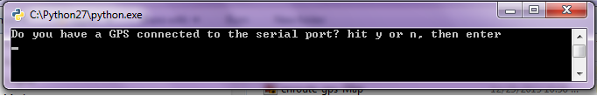
If you “Y” for yes and you don't have a GPS connected and you try to press, you will get out-of-bound errors from the parsing as shown below
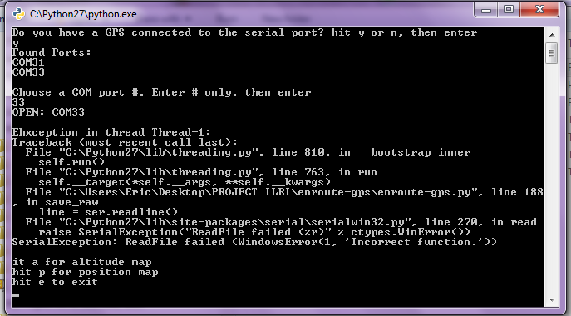
If you “n” for no and you don’t have a GPS connected and you press <Enter>, you will be presented with a menu as shown below
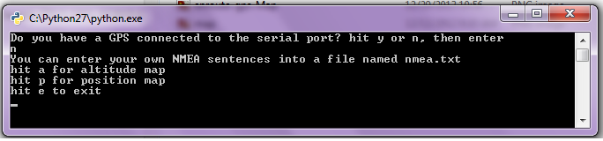

If your Choice was “a” for altitude The results will be as Shown Below:
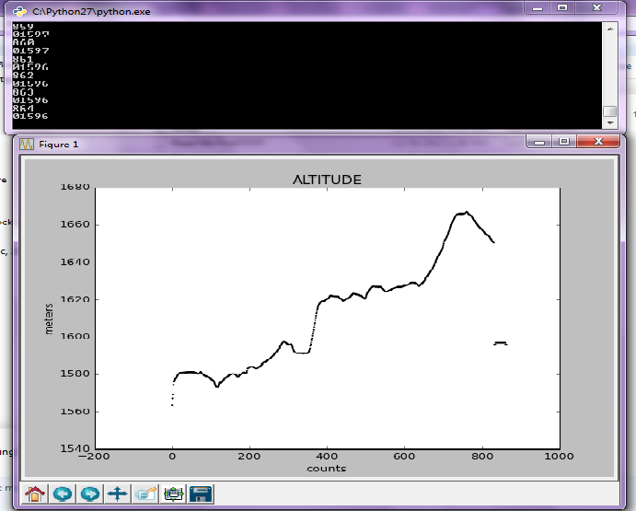
If your Choice was “a” The results will be as Shown Below:
